Netaji Subhas University of Technology



PRACTICAL FILE
INITC10 - DESIGN AND ANALYSIS OF ALGORITHM

Antriksh Jain – 2021UIN3326
Priyanshu Rana – 2021UIN3327
Yash Kumar – 2021UIN3328
Abhishek Maurya – 2021UIN3330
Harsh – 2021UIN3331
INDEX

S. No | Practical | Signature
1 | Write a Program to implement Merge sort
2 | Write a Program to implement Matrix Multiplication using Divide and Conquer strategy
3 | Write a Program to implement Knapsack Problem using Greedy Strategy
4 | Write a Program to find Minimum Spanning Tree of a given graph using Kruskal's Algorithm
5 | Write a Program to find Minimum Spanning Tree of a given graph using Prims Algorithm
6 | Write a Program to implement Floyd Warshall Algorithm
7 | Write a Program to implement Knapsack Problem using Dynamic Programming
8 | Write a Program to implement N queens Problem using Backtracking
9 | Write a Program to perform Travelling Salesman Problem
10 | Write a Program to implement Knapsack Problem using Branch and Bound
11 | Find a subset of a given set S = {s1, s2,...., sN} of n positive integers whose sum is equal to a given positive integer d
12 | Given a sequence of matrices, find the most efficient way to multiply these matrices together

Practical-1

Aim: Write a Program to implement Merge sort

Software Used: VS Code editor
Language Used: C++

Code:

#include<bits/stdc++.h>
using namespace std;

void merge(int* A, int s, int m, int e) {
int i = s;
int j = m+1;
int k = s;

int B[100];

while(i <= m && j <= e) {
if(A[i] < A[j])
B[k++] = A[i++];
else
B[k++] = A[j++];
}

while(i <= m)
B[k++] = A[i++];

while(j <= e)
B[k++] = A[j++];

for(int i=s; i<=e; i++) {
A[i] = B[i];
}

}

void f(int* A, int s, int e) {
// base case
if(s >= e)
return;

// recursive case

// 1. Divide the array around the mid-point
int m = s + (e-s)/2;

// 2. Recursively sort the two subarrays
f(A, s, m);
f(A, m+1, e);

// 3. Merge the two sorted subarrays
merge(A, s, m, e);

}

int main() {

int A[] = {5, 4, 3, 2, 1};
int n = sizeof(A) / sizeof(int);

cout << "Original Array: ";
for(int i=0; i<n; i++) {
cout << A[i] << " ";
}

cout << endl;

f(A, 0, n-1);

cout << "Sorted Array: ";
for(int i=0; i<n; i++) {
cout << A[i] << " ";
}
cout << endl;

return 0;
}

Output:

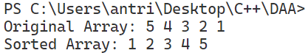

Practical-2

Aim: Write a Program to implement Matrix Multiplication using Divide and Conquer strategy

Software Used: VS Code editor
Language Used: C++

Code:

#include<bits/stdc++.h>
using namespace std;

int **Matrix(int n)
{
int **temp = new int *[n];
for (int i = 0; i < n; i++)
temp[i] = new int[n];
return temp;
}

int **DivideAndConquer(int **A, int **B, int n){
if(n == 1){
int **C = Matrix(1);
C[0][0] = A[0][0] * B[0][0];
return C;
}
int **C = Matrix(n);
int k = n / 2;

int **A11 = Matrix(k);
int **A12 = Matrix(k);
int **A21 = Matrix(k);
int **A22 = Matrix(k);
int **B11 = Matrix(k);
int **B12 = Matrix(k);
int **B21 = Matrix(k);
int **B22 = Matrix(k);

for(int i=0; i<k; i++){
for(int j=0; j<k; j++){
A11[i][j] = A[i][j];
A12[i][j] = A[i][j+k];
A21[i][j] = A[i+k][j];
A22[i][j] = A[i+k][j+k];
B11[i][j] = B[i][j];
B12[i][j] = B[i][j+k];
B21[i][j] = B[i+k][j];
B22[i][j] = B[i+k][j+k];
}
}

int **P1 = DivideAndConquer(A11,B11,k);
int **P2 = DivideAndConquer(A12,B21,k);
int **P3 = DivideAndConquer(A11,B12,k);
int **P4 = DivideAndConquer(A12,B22,k);
int **P5 = DivideAndConquer(A21,B11,k);
int **P6 = DivideAndConquer(A22,B21,k);
int **P7 = DivideAndConquer(A21,B12,k);
int **P8 = DivideAndConquer(A22,B22,k);

for(int i=0; i<k; i++){
for(int j=0; j<k; j++){
C[i][j] = P1[i][j] + P2[i][j];
C[i][j+k] = P3[i][j] + P4[i][j];
C[i+k][j] = P5[i][j] + P6[i][j];
C[i+k][j+k] = P7[i][j] + P8[i][j];
}
}

return C;
}

int main(){
int size;
cout << "Enter the size of matrix(in powers of 2): ";
cin >> size;

int **A = Matrix(size);
int **B = Matrix(size);
int **C = Matrix(size);

cout << "Enter the elements of matrix A: " << endl;
for(int i=0; i<size; i++){
for(int j=0; j<size; j++){
cin >> A[i][j];
}
}

cout << "Enter the elements of matrix B: " << endl;
for(int i=0; i<size; i++){
for(int j=0; j<size; j++){
cin >> B[i][j];
}
}

C = DivideAndConquer(A,B,size);

cout << "The product of matrix A and B is: " << endl;
for(int i=0; i<size; i++){
for(int j=0; j<size; j++){
cout << C[i][j] << " ";
}
cout << endl;
}
return 0;
}

Output:

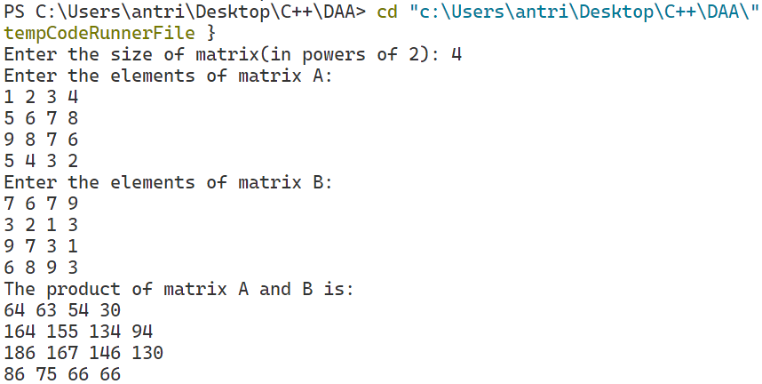

Practical-3

Aim: Write a Program to implement Knapsack Problem using Greedy Strategy

Software Used: VS Code editor
Language Used: C++

Code:

#include<bits/stdc++.h>
using namespace std;

class Item{
public:
int value;
int weight;

Item(int value, int weight){
this->value = value;
this->weight = weight;
}
};

bool compare(Item a, Item b){ // comparator function(returns true when swap is not required)
double r1 = (double)a.value / a.weight;
double r2 = (double)b.value / b.weight;
return r1 > r2;
}

//using greedy approach
double fractionalKnapsack(int W, Item arr[], int n){
sort(arr, arr + n, compare);
int curWeight = 0;
double finalValue = 0.0;
for(int i=0; i<n; i++){
if(curWeight + arr[i].weight <= W){
curWeight += arr[i].weight;
finalValue += arr[i].value;
}
else{
int remain = W - curWeight;
finalValue += arr[i].value * ((double)remain / arr[i].weight);
break;
}
}
return finalValue;
}

int main(){
int W ;
cout << "Enter the capacity of the knapsack: ";
cin >> W;

int n;
cout << "Enter the number of items: ";
cin >> n;

Item* arr;
for(int i=0; i<n; i++){
int value, weight;
cout << "Enter the value and weight of item " << i+1 << ": ";
cin >> value >> weight;
arr[i] = Item(value, weight);
}
cout << endl;
cout << "Maximum value we can obtain = " << fractionalKnapsack(W, arr, n) << endl;

return 0;
}

Output:

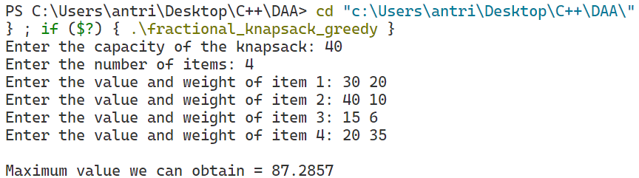

Practical-4

Aim: Write a Program to find Minimum Spanning Tree of a given graph using Kruskal's Algorithm

Software Used: VS Code editor
Language Used: C++

Code:

#include<bits/stdc++.h>
using namespace std;

bool cmp(vector<int> &a,vector<int> &b){
return a[2]<b[2];
}

int findParent(vector<int> &parent, int node){
if(parent[node]==node){
return node;
}
return parent[node] = findParent(parent, parent[node]);
}

void unionSet(int u, int v, vector<int> &parent, vector<int> &rank){
u = findParent(parent,u);
v = findParent(parent,v);

if(rank[u] < rank[v])
parent[u] = v;
else if(rank[v] < rank[u])
parent[v] = u;
else{
parent[v] = u;
rank[u]++;
}

}

int minimumSpanningTree(vector<vector<int>>& edges, int n)
{
sort(edges.begin(),edges.end(),cmp);
vector<int> parent(n);
vector<int> rank(n,0);
for(int i=0; i<n; i++){
parent[i] = i;
}
int minWeight = 0;
cout << endl << "Following are the edges in the constructed MST - " << endl;
for(int i=0; i<edges.size(); i++){
int u = findParent(parent,edges[i][0]);
int v = findParent(parent,edges[i][1]);
int wt = edges[i][2];
if(u!=v){
minWeight += wt;
unionSet(u, v, parent, rank);
cout << edges[i][0] << " " << edges[i][1] << endl;
}

}
cout << endl;
return minWeight;

}

int main(){
int n;
cout << "Enter number of vertices: ";
cin >> n;
int m;
cout << "Enter number of edges: ";
cin >> m;
vector<vector<int>> g;
for(int i=0; i<m; i++){
int u, v, w;
cout << "Enter the edge and weight: ";
cin >> u >> v >> w;
g.push_back({u,v,w});
}
cout << "Cost of Minimum Spanning Tree: " << minimumSpanningTree(g,n) << endl;
}

Output:

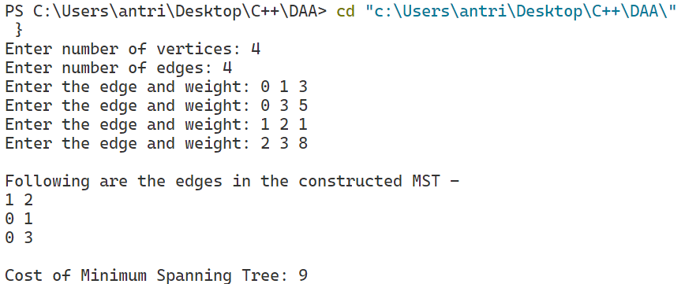

Practical-5

Aim: Write a Program to find Minimum Spanning Tree of a given graph using Prims Algorithm

Software Used: VS Code editor
Language Used: C++

Code:

#include<bits/stdc++.h>
using namespace std;

vector<pair<pair<int, int>, int>> calculatePrimsMST(int n, int m, vector<pair<pair<int, int>, int>> &g)
{
//create adj list
unordered_map<int, list<pair<int,int>>> adj;
for(int i=0; i<g.size(); i++){
int u = g[i].first.first;
int v = g[i].first.second;
int w = g[i].second;
adj[u].push_back(make_pair(v,w));
adj[v].push_back(make_pair(u,w));
}
vector<int> key(n+1,INT_MAX);
vector<bool> mst(n+1,false);
vector<int> parent(n+1,-1);

//algorithm
key[1] = 0;

for(int i=1; i<=n; i++){
int mini = INT_MAX;
int u;
for(int v=1; v<=n; v++){
if(mst[v] == false && key[v] < mini){
u = v;
mini = key[v];
}
}
mst[u] = true;
for(auto it: adj[u]){
int v = it.first;
int w = it.second;
if(mst[v] == false && key[v] > w ){
key[v] = w;
parent[v] = u;
}
}
}

vector<pair<pair<int, int>, int>> ans;

for(int i=2; i<=n; i++){
ans.push_back({{parent[i], i}, key[i]});
}
return ans;
}

int main(){
int n;
cout << "Enter number of vertices: ";
cin >> n;
int m;
cout << "Enter number of edges: ";
cin >> m;
vector<pair<pair<int, int>, int>> g;
for(int i=0; i<m; i++){
int u, v, w;
cout << "Enter the edge and weight: ";
cin >> u >> v >> w;
g.push_back({{u,v},w});
}
vector<pair<pair<int, int>, int>> ans = calculatePrimsMST(n, m, g);
cout << endl;
cout << "MST edges are: " << endl;
for(int i=0; i<ans.size(); i++){
cout << ans[i].first.first << " " << ans[i].first.second << " " << ans[i].second << endl;
}

return 0;
}

Output:
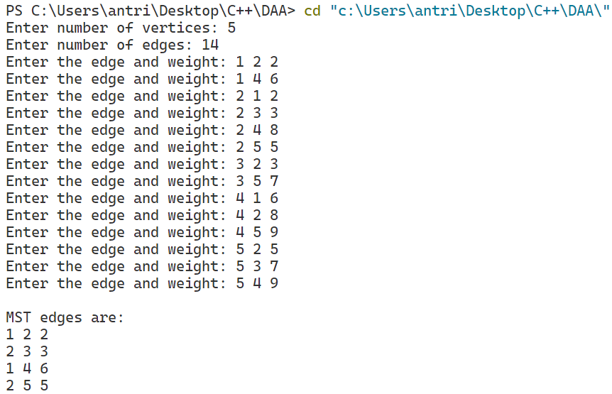

Practical-6

Aim: Write a Program to implement Floyd Warshall Algorithm

Software Used: VS Code editor
Language Used: C++

Code:

#include<bits/stdc++.h>
using namespace std;
int main(){
int n;
cout << "Enter number of vertices: ";
cin >> n;
int m;
cout << "Enter number of edges: ";
cin >> m;
vector<vector<int>> g(n+1, vector<int>(n+1, INT_MAX));
//Assuming Directed Graph
for(int i=0; i<m; i++){
int u, v, w;
cout << "Enter the edge and weight: ";
cin >> u >> v >> w;
g[u][v] = w;
}
for(int i=1; i<=n; i++){
g[i][i] = 0;
}
//Floyd Warshall Algorithm
for(int k=1; k<=n; k++){
for(int i=1; i<=n; i++){
for(int j=1; j<=n; j++){
if(g[i][k] != INT_MAX && g[k][j] != INT_MAX && g[i][k] + g[k][j] < g[i][j]){
g[i][j] = g[i][k] + g[k][j];
}
}
}
}
//Printing the distance matrix
cout << endl;
cout << "Distance Matrix: " << endl;
for(int i=1; i<=n; i++){
for(int j=1; j<=n; j++){
cout << g[i][j] << " ";
}
cout << endl;
}
return 0;
}

Output:

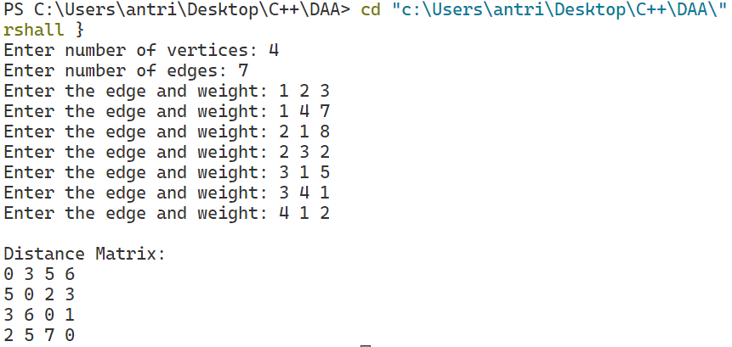

Practical-7

Aim: Write a Program to implement Knapsack Problem using Dynamic Programming

Software Used: VS Code editor
Language Used: C++

Code:

#include <bits/stdc++.h>
using namespace std;

int knapSack(int W, int wt[], int val[], int n){
int i, w;
vector<vector<int>> dp(n + 1, vector<int>(W + 1));
for (i = 0; i <= n; i++){
for (w = 0; w <= W; w++){
if (i == 0 || w == 0)
dp[i][w] = 0;
else if (wt[i - 1] <= w)
dp[i][w] = max(val[i - 1] + dp[i - 1][w - wt[i - 1]],
dp[i - 1][w]);
else
dp[i][w] = dp[i - 1][w];
}
}
return dp[n][W];
}

int main()
{
int items;
cout<<"Enter the number of items: ";
cin>>items;
int profit[items], weight[items];
for(int i=0; i<items; i++){
cout<<"Enter the profit and weight of item "<<i+1<<": ";
cin>>profit[i]>>weight[i];
}

int W;
cout<<"Enter the capacity of the knapsack: ";
cin>>W;

cout << "Maximum profit is: " << knapSack(W, weight, profit, items) << endl;

return 0;
}

Output:

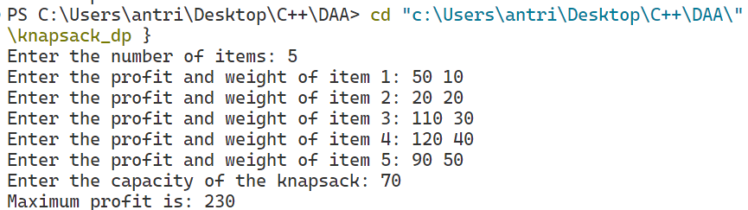

Practical-8

Aim: Write a Program to implement N queens Problem using Backtracking

Software Used: VS Code editor
Language Used: C++

Code:

#include<bits/stdc++.h>
using namespace std;

bool isSafe(int row, int col, vector<string>&board, int n){
int x = row, y = col;
//check row
while(y>=0){
if(board[x][y]=='Q') return false;
y--;
}

//top left diagonal
x = row, y = col;
while(x<n && y>=0){
if(board[x][y]=='Q') return false;
x++;
y--;
}

//bottom left diagonal
x = row, y = col;
while(x>=0 && y>=0){
if(board[x][y]=='Q') return false;
x--;
y--;
}
return true;
}

void solve(int col, vector<string> &board, int n, vector<vector<string>> &ans){
if(col==n){
ans.push_back(board);
return;
}
for(int row=0; row<n; row++){
if(isSafe(row,col,board,n)){
board[row][col]='Q';
solve(col+1, board, n, ans);
board[row][col]='.';
}
}
}

vector<vector<string>> solveNQueens(int n) {
string s;
for(int i=0; i<n; i++) s+='.';
vector<string> board(n,s);
vector<vector<string>> ans;
solve(0, board, n, ans);
return ans;
}
int main(){
int n;
cout<<"Enter the value of n: ";
cin>>n;
vector<vector<string>> ans = solveNQueens(n);
int cnt=1;
for(auto i: ans){
cout<<"\nSolution no. "<<cnt++<<endl;
for(auto j: i){
cout<<j<<endl;
}
cout<<endl;
}
return 0;
}

Output:

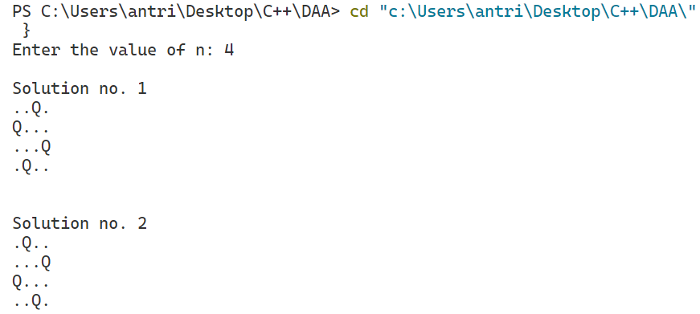

Practical-9

Aim: Write a Program to perform Travelling Salesman Problem

Software Used: VS Code editor
Language Used: C++

Code:

#include <bits/stdc++.h>
using namespace std;
#define V 4
int travllingSalesmanProblem(int graph[][V], int s)
{
vector<int> vertex;
for (int i = 0; i < V; i++)
if (i != s)
vertex.push_back(i);

int min_path = INT_MAX;
do {
int current_pathweight = 0;
int k = s;
for (int i = 0; i < vertex.size(); i++) {
current_pathweight += graph[k][vertex[i]];
k = vertex[i];
}
current_pathweight += graph[k][s];
min_path = min(min_path, current_pathweight);

} while (
next_permutation(vertex.begin(), vertex.end()));

return min_path;
}
int main()
{
int graph[][V] = { { 0, 20, 25, 10 },
{ 20, 0, 35, 15 },
{ 25, 35, 0, 30 },
{ 20, 15, 30, 0 } };
int s = 0;
cout << "Distance Matrix: " << endl;
for (int i = 0; i < V; i++) {
for (int j = 0; j < V; j++)
cout << graph[i][j] << " ";
cout << endl;
}
cout << endl;

cout << "Shortest Path is: " << travllingSalesmanProblem(graph, s);
return 0;
}

Output:

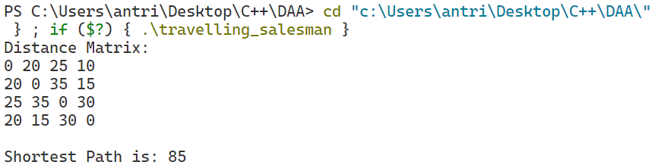

Practical-10

Aim: Write a Program to implement Knapsack Problem using Branch and Bound

Software Used: VS Code editor
Language Used: C++

Code:

#include <bits/stdc++.h>
using namespace std;

struct Item{
float weight;
int value;
};

struct Node{
int level, profit, bound;
float weight;
};

bool cmp(Item a, Item b){
double r1 = (double)a.value / a.weight;
double r2 = (double)b.value / b.weight;
return r1 > r2;
}

int bound(Node u, int n, int W, Item arr[]){
if (u.weight >= W)
return 0;

int profit_bound = u.profit;
int j = u.level + 1;
int totweight = u.weight;

while ((j < n) && (totweight + arr[j].weight <= W))
{
totweight += arr[j].weight;
profit_bound += arr[j].value;
j++;
}

if (j < n)
profit_bound += (W - totweight) * arr[j].value/arr[j].weight;

return profit_bound;
}

int knapsack(int W, Item arr[], int n){
sort(arr, arr + n, cmp);

queue<Node> Q;
Node u, v;

u.level = -1;
u.profit = u.weight = 0;
Q.push(u);

int maxProfit = 0;
while (!Q.empty())
{
u = Q.front();
Q.pop();

if (u.level == -1) v.level = 0;
if (u.level == n-1) continue;

v.level = u.level + 1;
v.weight = u.weight + arr[v.level].weight;
v.profit = u.profit + arr[v.level].value;

if (v.weight <= W && v.profit > maxProfit)
maxProfit = v.profit;

v.bound = bound(v, n, W, arr);

if (v.bound > maxProfit)
Q.push(v);

v.weight = u.weight;
v.profit = u.profit;
v.bound = bound(v, n, W, arr);
if (v.bound > maxProfit)
Q.push(v);
}

return maxProfit;
}

int main(){

int n;
cout<<"Enter the number of items: ";
cin>>n;
Item arr[n];

for(int i=0;i<n;i++)
{
cout<<"Enter the weight and value of item "<<i+1<<": ";
cin>>arr[i].weight>>arr[i].value;
}
int W;
cout<<"Enter the capacity of knapsack: ";
cin>>W;

cout << "Maximum possible profit = " << knapsack(W, arr, n);

return 0;
}

Output:

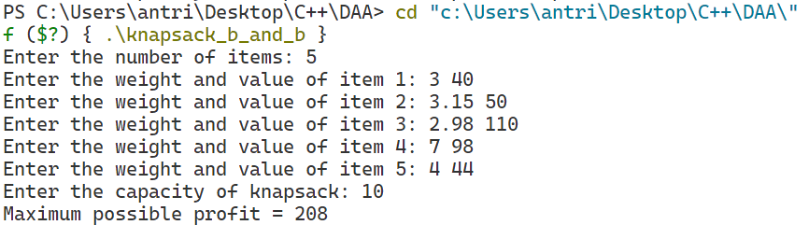

Practical-11

Aim: Find a subset of a given set S = {s1, s2,....., sN} of n positive integers whose sum is equal to a given positive integer d

Software Used: VS Code editor
Language Used: C++

Code:

#include <bits/stdc++.h>
using namespace std;

void solve(int n, vector<int>& v, int target, int i, set<vector<int>>&ans, vector<int> output){
//base case
if(target<0) return;
if(target==0){
ans.insert(output);
return;
}
if(i>=n) return;
//recursive case
for(int j = i; j < n; j++){
if(target-v[j]<0) break;
output.push_back(v[j]);
solve(n,v,target-v[j],j+1,ans, output);
output.pop_back();
while (j + 1 < v.size() && v[j] == v[j + 1]) j++;
}

}

int main() {
int n;
cout << "Enter the number of elements: ";
cin>>n;
vector<int> v(n);
cout << "Enter the elements: ";
for(int i=0; i<n; i++){
cin>>v[i];
}
sort(v.begin(),v.end());
int target;
cout << "Enter the target sum: ";
cin>>target;
set<vector<int>> ans;
vector<int> output;
solve(n,v,target,0, ans, output);

cout << endl << "The subsets are: " << endl;
for(auto it: ans){
cout << "[";
for(int i=0; i<it.size(); i++){
cout << it[i];
if(i!=it.size()-1) cout << ", ";
}
cout << "]" << endl;
}

return 0;
}

Output:

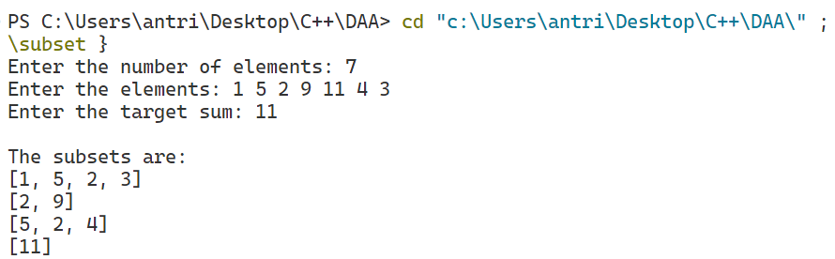

Practical-12

Aim: Given a sequence of matrices, find the most efficient way to multiply these matrices together

Software Used: VS Code editor
Language Used: C++

Code:

#include <bits/stdc++.h>
using namespace std;

int matrixChainMemoised(vector<int>&p, int i, int j, vector<vector<int>>&dp){
if(i == j){
return 0;
}
if(dp[i][j] != -1){
return dp[i][j];
}
dp[i][j] = INT_MAX;
for(int k=i; k<j; k++){
dp[i][j] = min(dp[i][j], matrixChainMemoised(p, i, k,dp) +
matrixChainMemoised(p, k+1, j,dp) + p[i-1]*p[k]*p[j]);
}
return dp[i][j];
}

int main(){
int n;
cout << "Enter the number of matrices: ";
cin >> n;
vector<int> v(n);
cout << "Enter the dimensions of the matrices: ";
for(int i=0; i<n; i++){
cin >> v[i];
}
vector<vector<int>> dp(n+1, vector<int>(n+1, -1));
cout << "The minimum number of multiplications is: " << matrixChainMemoised(v, 1, n-1,dp) << endl;
return 0;
}

Output:

